**VISVESVARAYA TECHNOLOGICAL UNIVERSITY**



## “Jnana Sangama”, Belgaum – 590 018

**A PROJECT REPORT ON**

## “Chronic Kidney Disease Identification in HIV Infected Patients using Machine Learning ”

Submitted in partial fulfillment for the award of the degree of

**BACHELOR OF ENGINEERING IN**

**INFORMATION SCIENCE AND ENGINEERING BY**

### Jaichandran J(1CR18IS065)

### Maruth Kumar V(1CR18IS089)

***Under the guidance of***

### Mrs.Rashmi D

(Assistant Professor, Dept. of ISE, CMRIT)

### DEPARTMENT OF COMPUTER SCIENCE & ENGINEERING CMR INSTITUTE OF TECHNOLOGY,

**BANGALORE-37**



### Department of Information Science & Engineering

Certificate

This is to certify that the project entitled **“Chronic Kidney Disease Identification in HIV Infected Patients using Machine Learning ”** has been successfully completed by **Mr. Jaichandran J, USN 1CR18IS065 and Mr. Maruth Kumar V, USN 1CR18IS089,** bonafide students of CMR Institute of Technology in partial fulfillment of the requirements for the award of degree of Bachelor of Engineering in **Information Science and Engineering** of the Visvesvaraya Technological University, Belgaum during the academic year 2021-2022. It is certified that all the corrections/suggestions indicated for Internal Assessment have been incorporated in the project report. The project report has been approved as it satisfies the academic requirements in respect of project work prescribed for the said degree.

|  |  |  |
| --- | --- | --- |
| Name & Signature of Guide | Name & Signature of HOD | Signature of Principal |
| (Mrs. Rashmi D) | (Dr. M. Farida Begam) | (Dr.Sanjay Jain) |
|  | **External Viva** |  |
| **Name of the Examiners** |  | **Signature with date** |
| 1. |  |  |
| 2. |  |  |



### Department of Information Science & Engineering

***DECLARATION***

We, **JaiChandran J(1CR18IS065)** and **Maruth Kumar V(1CR18IS089),** bonafide students of CMR Institute of Technology, Bangalore, hereby declare that the dissertation entitled, **“Chronic Kidney Disease Identification in HIV Infected Patients using Machine Learning”** has been carried out by us under the guidance of **Mrs. Rashmi D, Assistant Professor**, CMRIT, Bangalore, in partial fulfillment of the requirements for the award of the degree of Bachelor of Engineering in **Information Science Engineering**, of the Visvesvaraya Technological University, Belgaum during the academic year 2021-2022. The work done in this dissertation report is original and it has not been submitted for any other degree in any university.

Jai Chandran J (1CR18IS065)

Maruth Kumar V(1CR18IS089)

# ABSTRACT

Chronic Kidney Disease (CKD) is one of the deadliest diseases that slowly damages human kidney. The disease remains undetected in its early stage and the patients can only realize the severity of the disease when it gets advanced. Hence, detecting such disease at earlier stage is a key challenge now. Machine Learning is one of the emerging field used in the health sectors for the diagnosis of different diseases. In this paper, we compute, analyze and compare between Machine Learning classification approaches to determine which classification approach is the optimal for the prediction of CKD. K- Nearest Neighbor Classifier, Decision Tree Classifier, SVM, Logical Regression and SGD Classifier are some renowned machine learning methods which were selected to train the model and based on these results, HIV can poses devastating effects on your kidney This damages to kidney are further worsened by HIV medications People living with HIV are more likely to get diabetes than people without it. Kidney disease can advance to kidney failure. The treatments for kidney failure are dialysis and a kidney transplant. Both treatments are used to treat kidney failure in people infected with HIV.

**Keywords:** Chronic Kidney Disease ,HIV, K-nearest Neighbor, SGD, Decision tree classifier, SVM, Logical Regression, Naïve Bayes

The satisfaction and euphoria that accompany a successful completion of any task would be incomplete without the mention of people who made it possible, success is the epitome of hard work and perseverance, but steadfast of all is encouraging guidance.

So, it is with gratitude that we acknowledge all those whose guidance and encouragement served as beacon of light and crowned our effort with success.

We would like to thank **Dr. Sanjay Jain,** Principal, CMRIT, Bangalore, for providing an excellent academic environment in the college and his never-ending support for the B.E program.

We would like to express our gratitude towards **Dr. M. Farida Begam,** Professor and HOD, Department of Information Science and Engineering CMRIT, Bangalore, who provided guidance and gave valuable suggestions regarding the project.

We consider it a privilege and honor to express our sincere gratitude to our internal guide **Mrs. Rashmi D,** Assistant Professor, Department of Information Science and Engineering, CMRIT, Bangalore for their valuable guidance throughout the tenure of this project work.

We would also like to thank all the faculty members who have always been very Co- operative and generous. Conclusively, we also thank all the non-teaching staff and all others who have done immense help directly or indirectly during our project.

**JAI CHANDRAN J**

**MARUTH KUMAR V**

|  |  |
| --- | --- |
| **Abstract** | **i** |
| **Table of Contents** | **ii** |
| **List of Figures** | **iv** |
|  |  |
| **1 Preamble** | **1** |
| 1.1 Introduction . . . . . . . . . . . . . . . . . . . . . . . . . . . . . . . . . | 1 |
| 1.2 Existing System . . . . . . . . . . . . . . . . . . . . . . . . . . . . . . . | 1 |
| 1.3 Proposed System . . . . . . . . . . . . . . . . . . . . . . . . . . . . . . | 2 |
| 1.4 Plan of Implementation . . . . . . . . . . . . . . . . . . . . . . . . . . . | 2 |
| 1.5 Problem Statement . . . . . . . . . . . . . . . . . . . . . . . . . . . . . | 2 |
| 1.6 Objective of the Project . . . . . . . . . . . . . . . . . . . . . . . . . . | 3 |
| **2 Literature Survey** | **4** |
| **3 Theoretical Background** | **6** |
| **4 System Requirements Specification** | **14** |
| 4.1 Functional Requirement . . . . . . . . . . . . . . . . . . . . . . . . . . | 15 |
| 4.2 Non Functional Requirements . . . . . . . . . . . . . . . . . . . . . . . | 15 |
| **5 System Analysis** | **18** |
| 5.1 Feasibility Study . . . . . . . . . . . . . . . . . . . . . . . . . . . . . . | 18 |
| 5.2 Analysis . . . . . . . . . . . . . . . . . . . . . . . . . . . . . . . . . . . | 20 |
| **6 System Design** | **21** |
| 6.1 System Development Methodology . . . . . . . . . . . . . . . . . . . . | 21 |
| 6.2 Model phases . . . . . . . . . .. . . . . . . . . . . . . . . . . . . . . . . . . . . . | 22 |
| 6.3 System Architecture . . . . . . . . . . . . . . . . . . . . . . . . . . | 24 |
| 6.4 Dataflow diagram . . . . . . . . . . . . . . . . . . . . . . . . . . . . . . . . . | 25 |

* 1. Use Case Diagram 26
  2. Sequence Diagram 27
  3. Class Diagram 28

1. Implementation 29
2. Testing 36
   1. Testing Methodologies 36
   2. Unit Testing 36
   3. System Testing 37
   4. Quality Assurance 37
   5. Functional Test 38
3. Results and Performance Analysis 39
4. Conclusion 45

# List of Figures

|  |  |
| --- | --- |
| 3.4 List of dataset | 10 |
| 6.2 Waterfall Model | 23 |
| 6.3 System Architecture | 24 |
| 6.4 Data flow Diagram | 25 |
| 6.5 Use Case Diagram | 26 |
| 6.6 Sequence Diagram | 27 |
| 6.7 Class Diagram | 28 |
| 7.1 Dataset | 29 |
| 7.2 Data pre-processing | 31 |
| 7.3 Different models used like decision tree, logistic regression | 34 |
| 9.1 Accuracy Comparison | 39 |
| 9.2 Remote User | 40 |
| 9.3 Service provider | 41 |
| 9.4 Snapshots of output | 42 |
|  |  |
|  |  |
|  |  |
|  |  |
|  |  |

## CHAPTER 1

* 1. **Introduction**

# PREAMBLE

Two bean-shaped organs, named kidney, are two important parts in human body. Kidney removes waste from blood by filtering. If this filtering system is hampered, protein can seep to urine and waste elements can remain in blood. And gradually, kidney loses its ability to filter. This failure of kidney is called Chronic Kidney Disease (CKD), also known as Chronic Renal Disease. Whole body is affected by kidney failure. Generally people suffer with this disease with their age, but recently from 5 years children and youth are also suffering from CKD disease. There are some symptoms which shows kidneys are beginning to fail like muscle cramps, nausea and vomiting, appetite losses, swelling in your feet and ankles, too much urine or not enough urine, trouble catching your breath, trouble sleeping, fever and vomiting. Risk factors of CKD are diabetes, smoking, lack of sleeping, hyper- tension, improper diet, etc. Among them diabetes is the more dangerous factor. At the last stage, the patient must take dialysis or do kidney transplantation. One of the best ways to reduce this death rate is early treatment. Therefore, early prediction and proper treatments can possibly stop, or slow the progression of this chronic disease.

## Existing System

To predict diseases, data mining or machine learning models are playing a vital role. By making some mathematical approaches, data mining models extract patterns from data and later these patterns are used for the survival of patients. Multilayer Perceptron (MP), Support Vector Machine (SVM), K- Nearest Neighbour (KNN), Logistic Regression (LR), Naïve Bayes (NB), Random Forest (RF), etc. are some renowned machine learning methods which were successfully implemented to examine and classify the kidney disease. IN recent times, some researchers have been working on CKD by applying different computational techniques for the prediction and diagnosis of this disease.

### Drawbacks

Machine learning algorithms can build complex models and make accurate decisions when given relevant data. When there is an adequate amount of data, the performance of machine learning

algorithms is expected to be sufficiently satisfactory. However, in specific applications, the data are often insufficient. Therefore, it is important to analyse these algorithms and obtain good results with a relatively small sample size.

## Proposed System

To develop a machine learning web application in which contain remote user and service provider where user can upload dataset compare using different machine learning algorithm such as have K-Nearest Neighbour Classifier, Decision Tree Classifier, Gaussian Naïve Bayes, Logical Regression and SVM, SGD to train the model. Then, based on the results of each of these Machine Learning Methods, we can compare and determine which among the following methods can predict the possibility of CKD most accurately.

## Plan of Implementation

The steps involved in this system implementation are:-

1. Dataset selection and Data Preprocessing – Selection of the correct dataset and preprocessing the data to remove any noise,.
2. Execution of Algorithms – Implement the algorithms for the given dataset. KNN, Decision Tree, SVM, SGD,Naïve Bayes, Logistic regression is used to compare the results and come up with the best method.
3. Classification of control metrics and predicting the most effective algorithm – Compare the performance of the algorithms based on the several control metrics. Plot the graphs depicting actual and predicted values and determine the most effective algorithm.

## Problem Statement

From last 15 years data it has been noticed that increase in number of patient which is suffering from CKD disease and more than 60% patients are not receiving medical attention. CKD ranks number 27 and 18 in 1990 and 2010 respectively as world’s prime reason of death. 956,000 people died in 2013 because of CKD. At the last stage, the patient must take dialysis or do kidney transplantation. One of the best ways to reduce this death rate is early treatment. But in developing countries, patients take treatment when they reached in serious state. An automated system can be built in order to detect CKD affected patients before reaching in last stage. Our aim is to compute, analyze and compare between

Machine Learning classification approaches to determine which classification approach is the optimal for prediction of chronic kidney disease.

## Objective of the Project

* CKD remains undetected in its early stage and the patients can only realize the severity of the disease when it gets advanced.
* Hence, detecting such disease at earlier stage is a key challenge now.
* This project helps to raise awareness among people and to promote early diagnosis.
* Early prediction and proper treatments can possibly stop, or slow the progression of this chronic disease.

**Chapter 2**

# LITERATURE SURVEY

In order to get required knowledge about various concepts related to the present application, existing literature were studied. Some of the important conclusions were made through those are listed below.

1. **Prediction of Chronic Kidney Disease using Random Forest Machine Learning Algorithm Author: Prof. Manish Kumar**

In this paper, CKD is being predicted using a Machine Learning Technique called Random Forest Algorithm. Random Forests are a combination of tree predictors so that all the trees depend on random vector sampled autonomously. Many other algorithms like SVM and Naïve Bayes were also used, but Random Forest was the most accurate.

1. **Chronic Kidney Disease Prediction using Machine Learning Models Author: Prof. S. Revathy**

In this paper, CKD prediction was made using Decision Trees, Random Forrest and Support Vector Machine algorithms. All the three algorithms were tested to check the highest accurate algorithm. Random Forrest is the most accurate followed by SVM and decision trees.

1. **Comparative study of classification Algorithms in Chronic Kidney Disease Author: Prof. Pratibha Devishri S**

In this paper, CKD prediction is done using performance measures like Kappa statistics, Receiver Operating Characteristic, Mean Absolute Error and Root mean squared Error using WEKA. Classifiers to be examined are created using Decision stamp, Rep tree, IBK, K-star, SGD and SMO. It is understood that Decision stump and Rep tree are giving better results.

1. **A survey on Chronic Kidney Disease detection using Novel Methods Author: Prof. K Dharmarajan**

In this paper, CKD is being predicted using multiple Machine Learning Techniques. Some of the techniques are Naïve Bayes, SVM, MBPN, LDA, KNN, etc. This survey confirmed that all these techniques successfully predicted with reasonable margin of error.

1. **Rule Induction and Prediction of Chronic Kidney Disease Using Boosting Classifiers, Ant-Miner and J48 Decision Tree Author: Prof. Arif-Ul-Islam and Shamim H. Ripon**

In this paper, CKD is being predicted using Boosting classifiers like AdaBoost and rule induction techniques like Ant-Miners. Boosting algorithm is an ensemble type machine learning algorithm which converts weak classifiers to strong model to achieve a better accuracy. Researches showed that many data mining techniques had been applied for CKD classification. Among those algorithms, AdaBoost classifier and J48 rule induction method performed well.

**Chapter 3**

# THEORITICAL BACKGROUND

## Overview on Machine Learning

Machine learning is an application of artificial intelligence (AI) that gives systems the ability to automatically learn and evolve from experience without being specially programmed by the programmer. The process of learning begins with observations or data, such as examples, direct experience, or instruction, in order to look for patterns in data and make better decisions in the future based on the examples that we provide. The main aim of machine learning is to allow computers to learn automatically and adjust their actions to improve the accuracy and usefulness of the program, without any human intervention or assistance. Traditional writing of programs for a computer can be defined as automating the procedures to be performed on input data in order to create output artifacts. Almost always, they are linear, procedural and logical. A traditional program is written in a programming language to some specification, and it has properties like:

* We know or can control the inputs to the program.
* We can specify how the program will achieve its goal.
* We can map out what decisions the program will make and under what conditions it makes them.
* Since we know the inputs as well as the expected outputs, we can be con dent that the program will achieve its goal

Traditional programming works on the premise that, as long as we can define what a program needs to do, we are confident we can define how a program can achieve that goal. This is not always the case as sometimes, however, there are problems that you can represent in a computer that you cannot write a traditional program to solve. Such problems resist a procedural and logical solution. They have properties such as:

* The scope of all possible inputs is not known beforehand.
* You cannot specify how to achieve the goal of the program, only what that goal is.
* You cannot map out all the decisions the program will need to make to achieve its goal.
* You can collect only sample input data but not all possible input data for the program.
  + 1. **Supervised and Unsupervised Learning**

Machine learning techniques can be broadly categorized into the following types:

Supervised learning takes a set of feature/label pairs, called the training set. From this training set the system creates a generalised model of the relationship between the set of descriptive features and the target features in the form of a program that contains a set of rules. The objective is to use the output program produced to predict the label for a previously unseen, unlabelled input set of features, i.e. to predict the outcome for some new data. Data with known labels, which have not been included in the training set, are classified by the generated model and the results are compared to the known labels. This dataset is called the test set. The accuracy of the predictive model can then be calculated as the proportion of the correct predictions the model labeled out of the total number of instances in the test set. Unsupervised learning takes a dataset of descriptive features without labels as a train- ing set. In unsupervised learning, the algorithms are left to themselves to discover interesting structures in the data. The goal now is to create a model that finds some hidden structure in the dataset, such as natural clusters or associations. Unsupervised learning studies how systems can infer a function to describe a hidden structure from unlabeled data. The system does not figure out the right output, but it explores the data and can draw inferences from datasets to describe hidden structures from unlabeled data. Unsupervised learning can be used for clustering, which is used to discover any inherent grouping that are already present in the data. It can also be used for association problems, by creating rules based on the data and finding relationships or associations between them. Semi- supervised machine learning falls somewhere in between supervised and unsupervised learning, since they use both labeled and unlabeled data for training typically a small amount of labeled data and a large amount of unlabeled data. The systems that use this method are able to considerably improve learning accuracy. Usually, semi-supervised learning is chosen when the acquired labeled data requires skilled and relevant resources in order to train it / learn from it. Otherwise, acquiring labeled data generally does not require additional resources.

Reinforcement machine learning algorithms is a learning method that interacts with its environment by producing actions and discovers errors or rewards. Machine learning algorithms are tools to

automatically make decisions from data in order to achieve some over-arching goal or requirement.

The promise of machine learning is that it can solve complex problems automatically, faster and more accurately than a manually specified solution, and at a larger scale. Over the past few decades, many machine learning algorithms have been developed by researchers, and new ones continue to emerge and old ones modified.

## Machine Learning Tools

There are many different software tools available to build machine learning models and to apply these models to new, unseen data. There are also a large number of well defined machine learning algorithms available. These tools typically contain libraries implementing some of the most popular machine learning algorithms. They can be categorized as follows :

* Pre-built application-based solutions.
* Programming languages which have specialized libraries for machine learning Using programming languages to develop and implement models is more flexible and gave us better control of the parameters to the algorithms. It also allows us to have a better understanding of the output models produced. Some of the popular programming languages used in the field of machine learning are:
* Python: Python is an extremely popular choice in the field of machine learning and AI development. Its short and simple syntax make it extremely easy to learn
* R: R is one of the most effective and efficient languages for analyzing and manipulating data in statistics. Using R, we can easily produce well-designed publication-quality plot, including mathematical symbols and formulae where needed. Apart from being a general purpose language, R has numerous of packages like RODBC, Gmodels, Class and Tm which are used in the field of machine learning. These packages make the implementation of machine learning algorithms easy, for cracking the business associated problems
* Tensor flow: Tensor Flow is an end-to-end open source platform for machine learning. It has a comprehensive, flexible ecosystem of tools, libraries, and community resources that lets researchers push the state-of-the-art in ML and developers easily build and deploy ML- powered applications. TensorFlow was originally developed by researchers and engineers working on the Google Brain team within Google’s Machine Intelligence Research organization to conduct machine learning and deep neural networks research. The system is

general enough to be applicable in a wide variety of other domains, as well. TensorFlow provides stable Python and C++ APIs, as well as non-guaranteed backward compatible.

API for other languages

## SciKit-learn

SciKit learn is an open source machine learning library built for python. Since its release in 2007, Scikit-learn has become one of the most popular open source machine learning libraries. Scikit-learn (also called sklearn) provides algorithms for many machine learning tasks including classification, regression, dimensionality reduction and clustering. The documentation for scikit-learn is comprehensive, popular and well maintained. Sklearn is built on mature Python Libraries such as NumPy, SciPy, and matplotlib. While languages such as R and MATLAB are extremely popular and useful for machine learning, we decided to choose Python along with its SciKit-learn libraries as our programming language of choice. The reasons for this are:

* We already have some familiarity and exposure to Python, and thus have a smaller learning curve.
* Both Python and Scikit-learn have excellent documentation and tutorials available online
* The number of classic machine learning algorithms that come with Scikit-learn, and the consistent patterns for using the different models i.e., each model can be used with the same basic commands for setting up the data, training the model and using the model for prediction. This makes it easier to try a range of machine learning algorithms on the same data.
* The machine learning algorithms included with sklearn have modifiable parameters known as hyper-parameters that effect the performance of the model. These usually have sensible default values, so that we can run them without needing a detailed knowledge or understanding of their semantics.
* The IPython notebook, which is an interactive computational environment for Python, in which a user can combine code execution, rich text, mathematics and plots in a web page. This functionality allows us to provide the notebooks we used to run our experiments almost as an audit and in a presentable.

## Dataset

For the system, the dataset was collected from a variety of source but the main source was UCI Repository. It contains 400 samples of patients having 24 attributes

Datasets include:-

|  |  |  |  |
| --- | --- | --- | --- |
| **Attribut e** | **Representation** | **Information Attribute** | **Description** |
| 1 | Age | Age | Numerical |
| 2 | Blood Pressure | Bp | Numerical |
| 3 | Specific Gravity | Sg | Nominal |
| 4 | Albumin | Al | Nominal |
| 5 | Sugar | Su | Nominal |
| 6 | Red Blood Cell | Rbc | Nominal |
| 7 | Pus Cell | Pc | Nominal |
| 8 | PusCellClumps | Pcc | Nominal |
| 9 | Bacteria | Ba | Nominal |
| 10 | Blood Glucose Random | Bgr | Numerical |
| 11 | Blood Urea | Bu | Numerical |
| 12 | Serum Creatinium | Sc | Numerical |
| 13 | Sodium | So | Numerical |
| 14 | Potassium | Pot | Numerical |
| 15 | Haemoglobin | hemo | Numerical |
| 16 | Packed Cell Volume | Pcv | Numerical |
| 17 | White Blood cell Count | Wc | Numerical |
| 18 | Red Blood Cell count | Rc | Numerical |
| 19 | Hypertension | Htn | Nominal |
| 20 | Diabetes Mellitus | Dm | Nominal |
| 21 | Coronary Artery Disease | Cad | Nominal |
| 22 | Appetite | appet | Nominal |
| 23 | Pedal Edema | Pe | Nominal |
| 24 | Anemia | Ane | Nominal |
| 25 | Class | Class | Nominal |

## Data Preprocessing

**Figure 3.1: List of dataset**

The data preprocessing involves cleaning, extracting, filling missing values and transformation to suitable formats. The cleaning is done through some standard tools available like WEKA. Table 2 show how the missing values are filled. We are using the label encoder and min-max algorithm to convert the nominal value to numeric value and bring all the attributes to the same scale respectively for better training.

|  |  |
| --- | --- |
| **Type of Attribute** | **Filled missing value** |
| Numeric | Average |
| Nominal | Mode |

**Figure 3.2: Table 2 (Missing values)**

## Machine Learning Algorithms

Machine Learning algorithms used in the recommendation system are:

1. **Logistic Regression:** Logistic Regression is the appropriate regression analysis to conduct when the dependent variable is dichotomous (binary). The logistic model (or logit model) is used to model the probability of a certain class or event existing such as pass/fail, win/lose, alive/dead or healthy/sick. This can be extended to model several classes of events such as determining whether an image contains a cat, dog, lion, etc. Each object being detected in the image would be assigned a probability between 0 and 1 and the sum adding to one.
2. **Support Vector Machine (SVM):** SVM is a supervised classification is one of the most important Machines Learning algorithms in Python, that plots a line that divides different categories of your data. In this ML algorithm, we calculate the vector to optimize the line. An SVM model is a representation of the examples as points in space, mapped so that the examples of the separate categories are divided by a clear gap that is as wide as possible. In addition to performing linear classification, SVMs can efficiently perform a non-linear classification using what is called the kernel trick, implicitly mapping their inputs into high-dimensional feature spaces. When data are unlabeled, supervised learning is not possible, and an unsupervised learning approach is required, which attempts to find natural clustering of the data to groups, and then map new data to these formed groups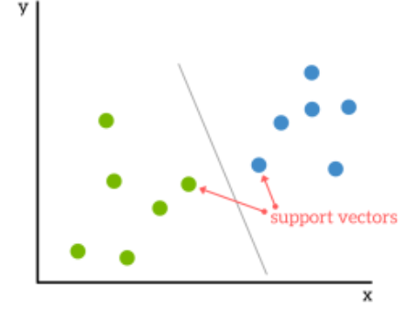
3. **Decision Tree:** Regression and classification problems. The general objective of using Decision Tree is to create a model that predicts classes or values of target variables by

generating decision rules derived from training data sets. Decision tree algorithm follows a tree structure with roots, branches and leaves. The attributes of decision making are the internal nodes and class labels are represented as leaf nodes. Decision Tree algorithm is easy to understand compared with other classification algorithms.

1. **KNN (K-nearest Neighbor):** In pattern recognition, the k-nearest neighbors algorithm (k-NN) is a non-parametric method used for classification and regression.[1] In both cases, the input consists of the k closest training examples in the feature space. The output depends on whether k-NN is used for classification or regression. In k-NN classification, the output is a class membership. An object is classified by a plurality vote of its neighbors, with the object being assigned to the class most common among its k nearest neighbors (k is a positive integer, typically small). If k = 1, then the object is simply assigned to the class of that single nearest neighbor.

In K-NN regression, the output is the property value for the object. This value is the average of the values of k nearest neighbors. K-NN is a type of instance based learning, or lazy learning, where the function is only approximated locally and all computation is deferred until function evaluation

1. **Stochastic Gradient Descent** (SGD): is a simple yet efficient optimization algorithm used to find the values of parameters/coefficients of functions that minimize a cost function. In other words, it is used for discriminative learning of linear classifiers under convex loss functions such as SVM and Logistic regression. It has been successfully applied to large-scale datasets because the update to the coefficients is performed for each training instance, rather than at the end of instances. SGD Classifier Stochastic Gradient Descent (SGD) classifier basically implements a plain SGD learning routine supporting various loss functions and penalties for classification. Scikit-learn provides SGDClassifier module to implement SGD classification.
2. **Naïve Bayes Algorithm**: Naive Bayes is a classification method which is based on Bayes’ theorem. This assumes independence between predictors. A Naive Bayes classifier will assume that a feature in a class is unrelated to any other. Consider a fruit. This is an apple if it is round, red, and 2.5 inches in diameter. A Naive Bayes classifier will say these characteristics independently contribute to the probability of the fruit being an apple. This is even if features depend on each other. For very large data sets, it is easy to build a Naive Bayesian model. Not only is this model very simple, it performs better than many highly sophisticated classification methods. Naïve Bayes classifiers are highly scalable, requiring a number of parameters linear in the number of variables(features/predictors) in a learning problem. Maximum-likelihood training can be done by evaluating a closed form expression, which takes linear time, rather than by expensive iterative approximation as used for many other types of classifiers.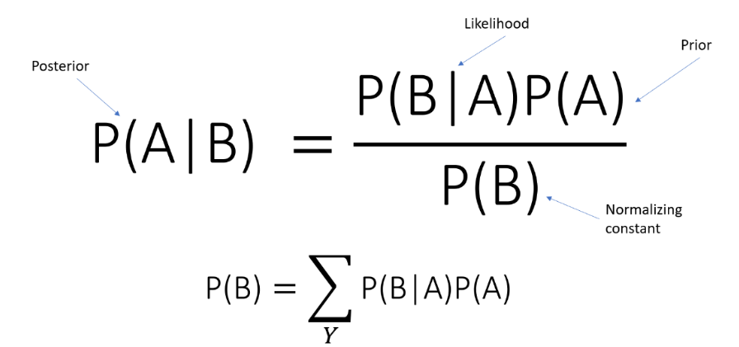

**Chapter 4**

# SYSTEM REQUIREMENT SPECIFICATION

A System Requirement Specification (SRS) is basically an organization’s understanding of a customer or potential client’s system requirements and dependencies at a particular point prior to any actual design or development work. The information gathered during the analysis is translated into a document that defines a set of requirements. It gives the brief description of the services that the system should provide and also the constraints under which, the system should operate. Generally, SRS is a document that completely describes what the proposed software should do without describing how the software will do it. It’s a two-way insurance policy that assures that both the client and the organization understand the other’s requirements from that perspective at a given point in time.

SRS document itself states in precise and explicit language those functions and capabilities a software system (i.e., a software application, an ecommerce website and so on) must provide, as well as states any required constraints by which the system must abide. SRS also functions as a blueprint for completing a project with as little cost growth as possible. SRS is often referred to as the “parent” document because all subsequent project management documents, such as design specifications, statements of work, software architecture specifications, testing and validation plans, and documentation plans, are related to it.

Requirement is a condition or capability to which the system must conform. Requirement Management is a systematic approach towards eliciting, organizing and documenting the requirements of the system clearly along with the applicable attributes. The elusive difficulties of requirements are not always obvious and can come from any number of sources.

## Functional Requirement

Functional Requirement defines a function of a software system and how the system must behave when presented with specific inputs or conditions. These may include calculations, data manipulation and processing and other specific functionality. In this system following are the functional requirements:-

1. All the data must be in the same format as a structured data.
2. The data collected will be vectorized and sent across to the classifier

### Non Functional Requirement

Non functional requirements are the requirements which are not directly concerned with the specific function delivered by the system. They specify the criteria that can be used to judge the operation of a system rather than specific behaviors. They may relate to emergent system properties such as reliability, response time and store occupancy. Non functional requirements arise through the user needs, because of budget constraints, organizational policies, the need for interoperability with other software and hardware systems or because of external factors such as:-

* + - Product Requirements
    - Organizational Requirements
    - User Requirements
    - Basic Operational Requirements

### Product Requirements

**Platform Independency: S**tandalone executables for embedded systems can be created so the algorithm developed using available products could be downloaded on the actual hardware and executed without any dependency to the development and modeling platform.

**Correctness:** It followed a well-defined set of procedures and rules to compute and also rigorous testing is performed to confirm the correctness of the data.

**Ease of Use:** Model Coder provides an interface which allows the user to interact in an easy manner.

**Modularity:** The complete product is broken up into many modules and well-defined interfaces are developed to explore the benefit of flexibility of the product.

**Robustness:** This software is being developed in such a way that the overall performance is optimized and the user can expect the results within a limited time with utmost relevancy and correctness

Non functional requirements are also called the qualities of a system. These qualities can be divided into execution quality & evolution quality. Execution qualities are security & usability of the system which are observed during run time, whereas evolution quality involves testability, maintainability, extensibility or scalability.

### Organizational Requirements

**Process Standards:** The standards defined by DRDO are used to develop the application which is the standard used by the developers inside the defense organization.

**Design Methods:** Design is one of the important stages in the software engineering process. This stage is the first step in moving from problem to the solution domain. In other words, starting with what is needed design takes us to work how to satisfy the needs.

### Basic Operational Requirements

The customers are those that perform the eight primary functions of systems engineering, with special emphasis on the operator as the key customer. Operational requirements will define the basic need and, at a minimum, will be related to these following points:-

**Mission profile or scenario:** It describes about the procedures used to accomplish mission

objective. It also finds out the effectiveness or efficiency of the system.

**Performance and related parameters:** It points out the critical system parameters to accomplish the mission

**Utilization environments:** It gives a brief outline of system usage. Finds out appropriate environments for effective system operation.

**Operational life cycle:** It defines the system lifetime.

### System Configuration

Hardware System Configuration:

* + - * Processor: 2 gigahertz (GHz) or faster processor or SoC.
      * RAM: 8 gigabyte (GB) for 32-bit or 8 GB for 64-bit.
      * Hard disk space: =16GB. Software Configuration:
* Operating System: Windows XP/7/8/8.1/10, Linux and Mac
* Coding Language: Python
* Designing: HTML, CSS, Java script
* Database: MYSQL(XAMPP)
* Tools:

1. Pandas
2. Numpy
3. Tensorflow
4. Sickitlearn

**Chapter 5**

# SYSTEM ANALYSIS

Analysis is the process of finding the best solution to the problem. System analysis is the process by which we learn about the existing problems, define objects and requirements and evaluates the solutions. It is the way of thinking about the organization and the problem it involves, a set of technologies that helps in solving these problems. Feasibility study plays an important role in system analysis which gives the target for design and development.

## Feasibility Study

All systems are feasible when provided with unlimited resource and infinite time. But unfortunately this condition does not prevail in practical world. So it is both necessary and prudent to evaluate the feasibility of the system at the earliest possible time. Months or years of effort, thousands of rupees and untold professional embarrassment can be averted if an ill- conceived system is recognized early in the definition phase. Feasibility & risk analysis are related in many ways. If project risk is great, the feasibility of producing quality software is reduced. In this case three key considerations involved in the feasibility analysis are

* + - Economical Feasibility
    - Technical Feasibility
    - Social Feasibility

### Economical Feasibility

This study is carried out to check the economic impact that the system will have on the organization. The amount of fund that the company can pour into the research and development of the system is limited. The expenditures must be justified. Since the project is Machine learning based, the cost spent in executing this project would not demand cost for software and related products, as most of the products are open source and free to use. Hence the project would consumed minimal cost and is economically feasible.

### Technical Feasibility

This study is carried out to check the technical feasibility, that is, the technical requirements of the system. Since machine learning algorithms is based on pure math there is very less requirement for any professional software. Also, most of the tools are open source. The best part is that we can run this software in any system without any software requirements which makes them highly portable. Most of the documentation and tutorials make easy to learn the technology.

### Social Feasibility

The aspect of study is to check the level of acceptance of the system by the user. This includes the process of training the user to use the system efficiently. The user must not feel threatened by the system, instead must accept it as a necessity. The main purpose of this project which is based on creating an early prediction system of Chronic Kidney Diseases using basic blood test reports. Our aim is help patients get early treatment based on these predictions which would save many lives. Thus, this is a noble cause for the sake of the society, a small step taken to achieve a secure and healthy future.

## Analysis

### 5.2.1 Performance Analysis

Most of the software we use is open source and free. The models which we use in this software only are trained once in the beginning and there is no need to fed again in for the training phase. One can directly predict for values. Hence time-complexity is very less. Therefore this model is temporally sound.

### Economical Analysis

Economic analysis is performed to evaluate the development cost weighed against the ultimate income or benefits derived from the developed system. The completion of this project can be considered free of cost in its entirety. As the software used in building the model is free of cost and all the data sets used are being downloaded from Kaggle and Govt. of India website.

### Technical Analysis

As mentioned earlier, the tools used in building this software is open source. Each tool contains simple methods and the required methods are overridden to tackle the problem.

**Chapter 6**

# SYSTEM DESIGN

Design is a meaningful engineering representation of something that is to be built. It is the most crucial phase in the developments of a system. Software design is a process through which the requirements are translated into a representation of software. Design is a place where design is fostered in software Engineering. Based on the user requirements and the detailed analysis of the existing system, the new system must be designed. This is the phase of system designing. Design is the perfect way to accurately translate a customer’s requirement in the finished software product. Design creates a representation or model, provides details about software data structure, architecture, interfaces and components that are necessary to implement a system. The logical system design arrived at as a result of systems analysis is converted into physical system design.

## System development methodology

System Development methodology is the development of a system or method for a unique situation. Having a proper methodology helps us in bridging the gap between the problem statement and turning it into a feasible solution. It is usually marked by converting the System Requirements Specifications (SRS) into a real-world solution. System design takes the following inputs:

* + - Statement of work.
    - Requirement determination plan.
    - Current situation analysis.
    - Proposed system requirements including a conceptual data model and metadata (data about data).

## Modal Phases

The waterfall model is a sequential software development process, in which progress is seen as owing steadily downwards (like a waterfall) through the phases of Requirement initiation, Analysis, Design, Implementation, Testing and maintenance.

* **Requirement Analysis**: This phase is concerned about collection of requirements of the system. This process involves generating document and requirement review.\
* **System Design**: Keeping the requirements in mind the system specifications are translated into a software representation. In this phase the designer emphasizes on:- algorithm, data structure, software architecture etc.
* **Coding**: In this phase programmer starts his coding in order to give a full sketch of product. In other words, system specifications are only converted into machine.
* **Implementation:** The implementation phase involves the actual coding or programming of the software. The output of this phase is typically the library, executables, user manuals and additional software documentation.
* **Testing:** In this phase all programs (models) are integrated and tested to ensure that the complete system meets the software requirements. The testing is concerned with verification and validation.
* **Maintenance:** The maintenance phase is the longest phase in which the software is updated to fulfill the changing customer need, adapt to accommodate change in the external environment, correct errors and oversights previously undetected in the testing phase, enhance the efficiency of the software.

### Advantages of the Waterfall Model

* + - * Clear project objectives.
      * Stable project requirements.
      * Progress of system is measurable.
      * Strict sign-off requirements.
      * Helps you to be perfect.
      * Logic of software development is clearly understood.
      * Production of a formal specification
      * Better resource allocation.

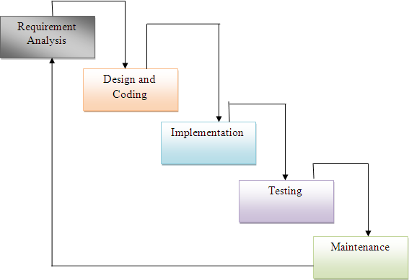

**Fig 6.2: Waterfall model**

## System Architecture

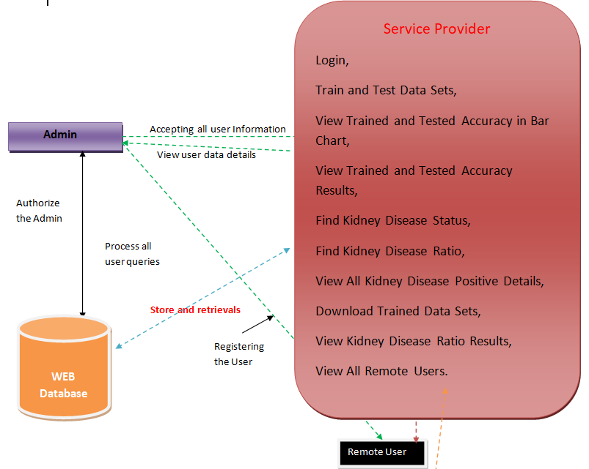

**Figure 6.2 System Architecture**

A system architecture is a conceptual model using which we can define the structure and behavior of that system. It is a formal representation of a system. Depending on the context, system architecture can be used to refer to either a model to describe the system or a method used to build the system. Building a proper system architecture helps in analysis of the project, especially in the early stages. Figure 6.2 depicts the system architecture and is explained in the following section.

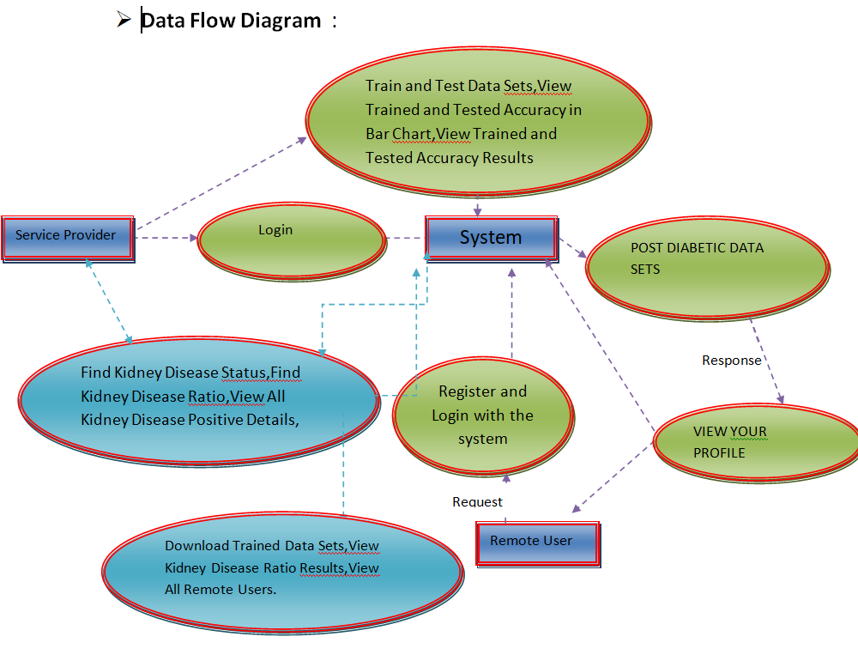**6.4 Data Flow Diagram**: A data-flow diagram is a way of representing a flow of data through a process or a system (usually an information system). The DFD also provides information about the outputs and inputs of each entity and the process itself.

Fig 6.4

**6.5 Use case diagram**

Fig 6.5

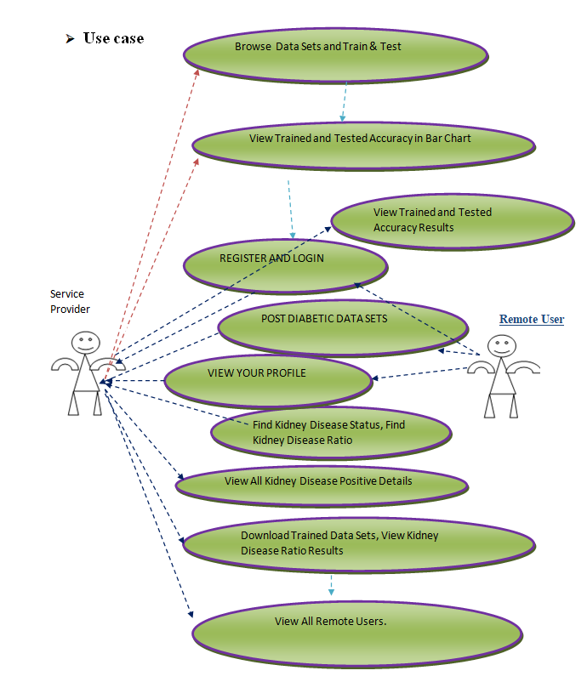

## 6.6 Sequence Diagram

A Sequence diagram is an interaction diagram that shows how processes operate with one another and what is their order. It is a construct of a Message Sequence Chart. A sequence diagram shows object interactions arranged in time sequence. It depicts the objects and classes involved in the scenario and the sequence of messages exchanged between the objects needed to carry out the functionality of the scenario. Sequence diagrams are typically associated with use case realizations in the Logical View of the system under development. Sequence diagrams are sometimes called event diagrams or event scenarios. Sequence diagram are an easy and intuitive way of describing the behavior of a system by viewing the interaction between the system and the environment. A sequence diagram shows an interaction arranged in a time sequence. A sequence diagram has two dimensions: vertical dimension represents time, the horizontal dimension represents the objects existence during the interaction.

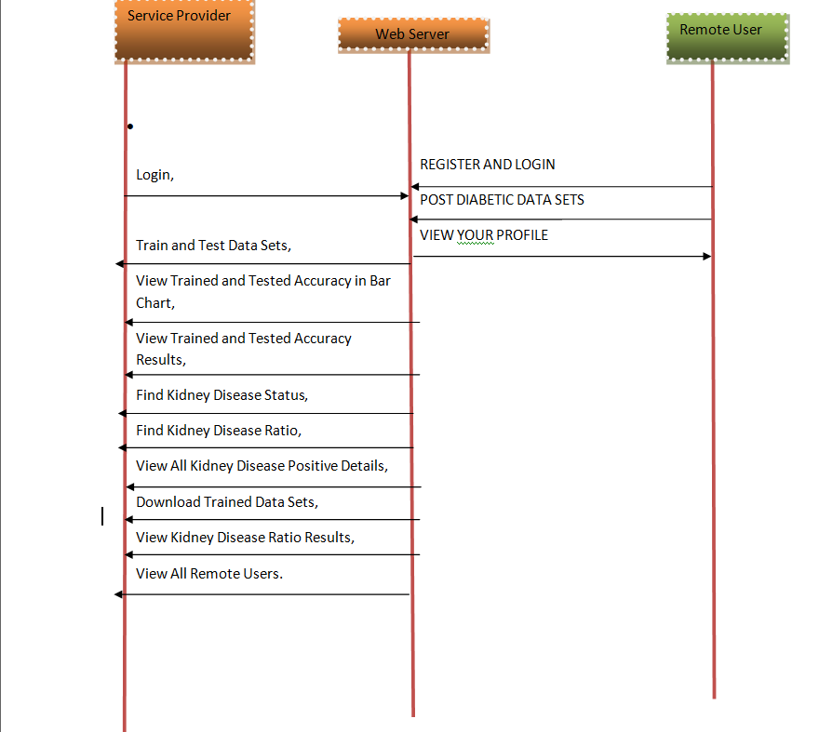

**Figure 6.6 Sequence Diagram** 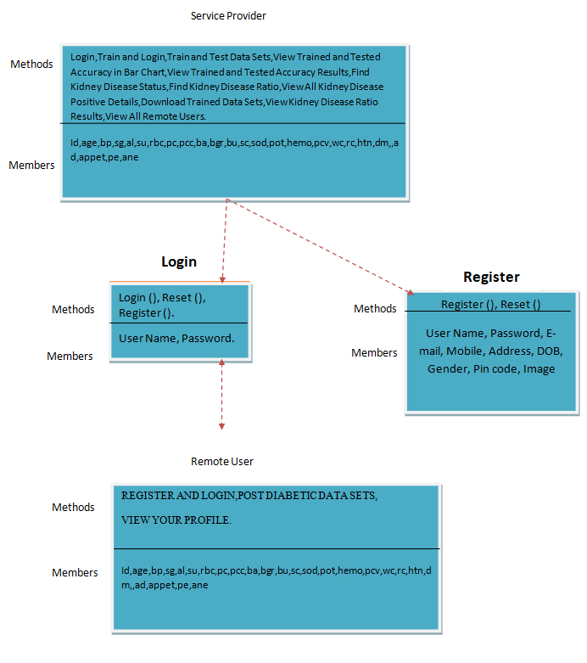

**Fig 6.7**

**6.7 Class diagram:**

Class diagrams are the blueprints of your system or subsystem. You can use class diagrams to model the objects that make up the system, to display the relationships between the objects, and to describe what those objects do and the services that they provide. Class diagrams are useful in many stages of system design**.**

**Chapter 7**

# IMPLEMENTATION

## Data Analysis

One of the first steps we perform during implementation is an analysis of the data. This was done by us in an attempt to find the presence of any relationships between the various attributes present in the dataset.

**Acquisition of Training Dataset**: The Training data set was acquired from the UCI Repository for kidney disease. The dataset was collected from a number of hospitals from Tamil Nadu and the values are actual test results values that were obtained. We have a total of 24 attributes which make up the dataset but on pre-processing it was found that only 6 of the 24 are important in determining that relationship. There are a total of 400 samples. This way the predictions can be used to correctly determine early detection of Chronic Kidney Disease.

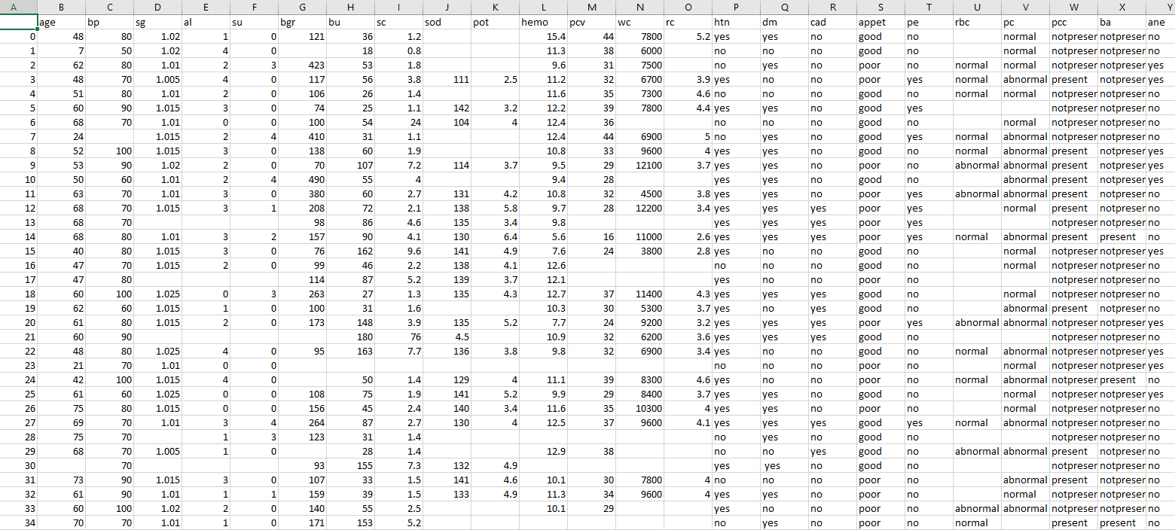

**Figure 7.1: Dataset**

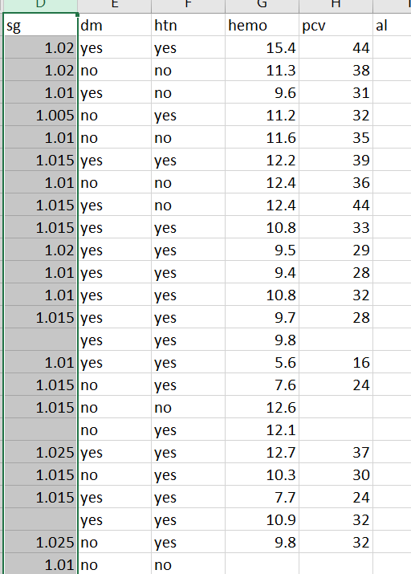

**Figure 7.1.1: Model Training dataset**

## Data Preprocessing

After analyzing and visualizing the data, the next step is preprocessing. Data preprocessing is an important step as it helps in cleaning the data and making it suitable for use in machine learning algorithms. Most of the focus in preprocessing is to remove any outliers or erroneous data, as well as handling any missing values. Missing data can be dealt with in two ways. The first method is to simply remove the entire row which contains the missing or erroneous value. While this an easy to execute method, it is better to use only on large datasets. Using this method on small datasets can reduce the dataset size too much, especially if there are a lot of missing values. This can severely affect the accuracy of the result. Since ours is a relatively small dataset, we will not be using this method. Instead we would be filling our missing values with average or mode of the column based on the type of attribute. If the attribute is nominal than we will use the average and if it is non-nominal we would be using the mode. The dataset that we used had values that were in string format so we had to transform and encode the into integer valued so as to pass as an input to the neural network. First we converted the data into pandas categorical data and create a separated dataframes. The steps for the above are illustratedbelow.

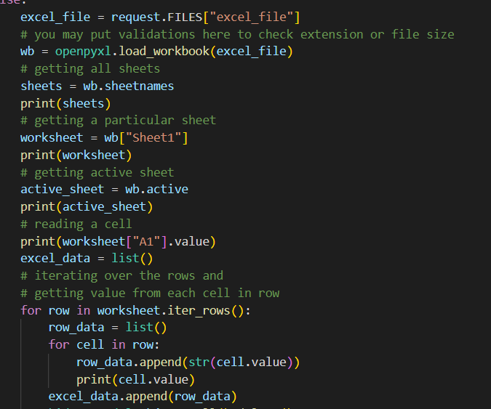

**Figure 7.2: Steps done for data pre-processing**

## Machine Learning Models

* + 1. **Decision Tree:** Regression and classification problems. The general objective of using Decision Tree is to create a model that predicts classes or values of target variables by generating decision rules derived from training data sets. Decision tree algorithm follows a tree structure with roots, branches and leaves. The attributes of decision making are the internal nodes and class labels are represented as leaf nodes. Decision Tree algorithm is easy to understand compared with other classification algorithms.
    2. **KNN (K-nearest Neighbor):** In pattern recognition, the k-nearest neighbors algorithm (k-NN) is a non-parametric method used for classification and regression.[1] In both cases, the input consists of the k closest training examples in the feature space. The output depends on whether k-NN is used for classification or regression. In k-NN classification, the output is a class membership. An object is classified by a plurality vote of its neighbors, with the object being assigned to the class most common among its k nearest neighbors (k is a positive integer, typically small). If k = 1, then the object is simply assigned to the class of that single nearest neighbor.In K-NN regression, the output is the property value for the object. This value is the average of the values of k nearest neighbors. K-NN is a type of instance based learning, or lazy learning, where the function is only approximated locally and all computation is deferred until function evaluation
    3. **Naïve Bayes:** In machine learning, naïve Bayes classifiers are a family of simple "probabilistic classifiers" based on applying Bayes' theorem with strong (naïve) independence assumptions between the features. They are among the simplest Bayesian network models.[1] But they could be coupled with Kernel density estimation and achieve higher accuracy levels. When dealing with continuous data, a typical assumption is that the continuous values associated with each class are distributed according to a normal (or Gaussian) distribution.
    4. **Naïve Bayes:** In machine learning, naïve Bayes classifiers are a family of simple "probabilistic classifiers" based on applying Bayes' theorem with strong (naïve) independence assumptions between the features. They are among the simplest Bayesian network models.[1] But they could be coupled with Kernel density estimation and achieve higher accuracy levels. When dealing with continuous data, a typical assumption is that the continuous values associated with each class are distributed according to a normal (or Gaussian) distribution.
    5. **Logistic Regression:** Logistic Regression is the appropriate regression analysis to conduct when the dependent variable is dichotomous (binary). The logistic model (or logit model) is used to model the probability of a certain class or event existing such as pass/fail, win/lose, alive/dead or healthy/sick. This can be extended to model several classes of events such as determining whether an image contains a cat, dog, lion, etc. Each object being detected in the image would be assigned a probability between 0 and 1 and the sum adding to one.
    6. **Support Vector Machine (SVM):** SVM is a supervised classification is one of the most important Machines Learning algorithms in Python, that plots a line that divides different categories of your data. In this ML algorithm, we calculate the vector to optimize the line. An SVM model is a representation of the examples as points in space, mapped so that the examples of the separate categories are divided by a clear gap that is as wide as possible. In addition to performing linear classification, SVMs can efficiently perform a non-linear classification using what is called the kernel trick, implicitly mapping their inputs into high-dimensional feature spaces. When data are unlabeled, supervised learning is not possible, and an unsupervised learning approach is required, which attempts to find natural clustering of the data to groups, and then map new data to these formed groups
    7. **Stochastic Gradient Descent** (SGD): is a simple yet efficient optimization algorithm used to find the values of parameters/coefficients of functions that minimize a cost function. In other words, it is used for discriminative learning of linear classifiers under convex loss functions such as SVM and Logistic regression. It has been successfully applied to large-scale datasets because the update to the coefficients is performed for each training instance, rather than at the end of instances. SGD Classifier Stochastic Gradient Descent (SGD) classifier basically implements a plain SGD learning routine supporting various loss functions and penalties for classification.

**Figure 7.3: Different models used like decision tree, logistic regression etc**

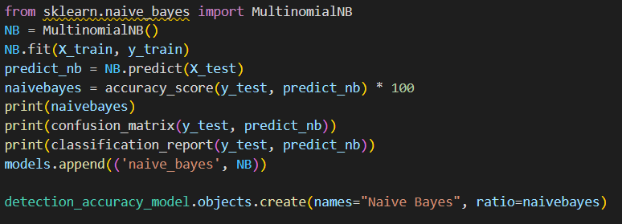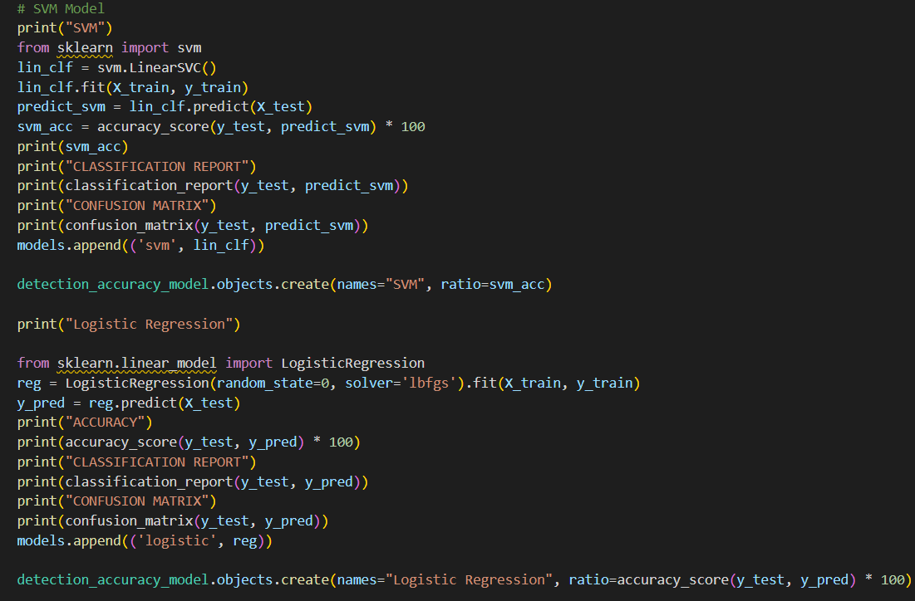

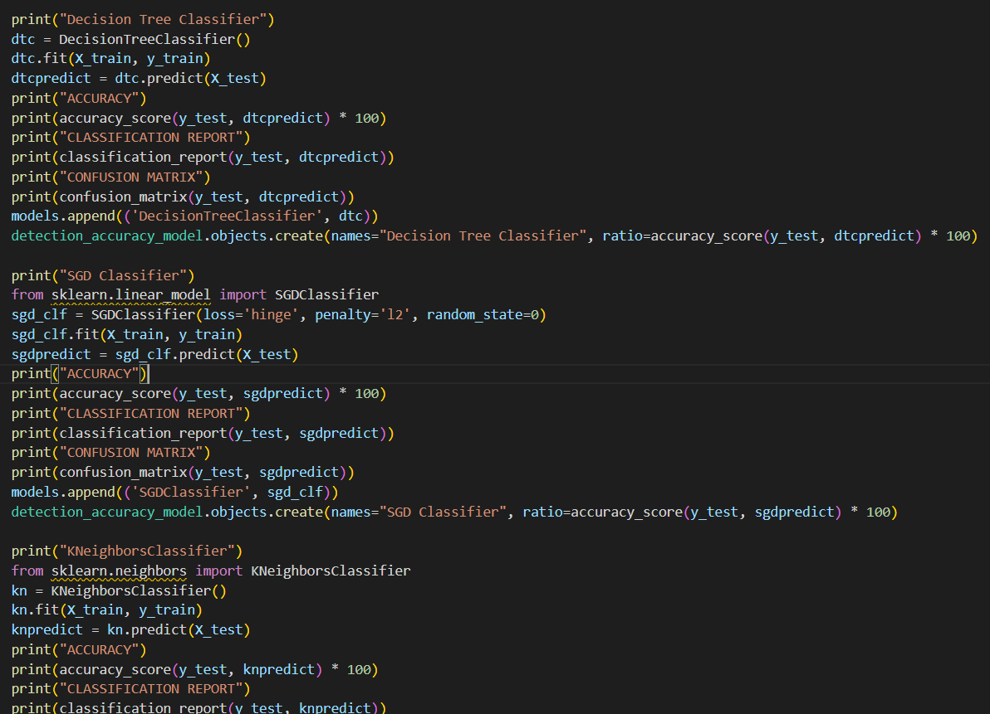

**Chapter 8**

# TESTING

System testing is actually a series of different tests whose primary purpose is to fully exercise the computer-based system. Although each test has a different purpose, all work to verify that all the system elements have been properly integrated and perform allocated functions. The testing process is actually carried out to make sure that the product exactly does the same thing what is supposed to do. In the testing stage following goals are tried to achieve:-

* To affirm the quality of the project.
* To find and eliminate any residual errors from previous stages.
* To validate the software as a solution to the original problem.
* To provide operational reliability of the system.

## Testing Methodologies

The program comprises of several algorithms which are tested individually for the accuracy. we check for the correctness of the program as a whole and how it performs.

### Unit testing

Unit tests focus on ensuring that the correct changes to the world- state take place when a transaction is processed. The business logic in transaction processor functions should have unit tests, ideally with 100 percent code coverage. This will ensure that you do not have ty- pos or logic errors in the business logic. The various modules can be individually run from a command line and tested for correctness. The tester can pass various values, to check the answer returned and verify it with the values given to him/her. The other work around is to write a script and run all the tests using it and write the output to a log file and using that to verify the results. We tested each of the algorithms individually and made changes in preprocessing accordingly to increase the accuracy.

### System Testing

Black System Testing is a level of software testing where a complete and in- tegrated software is tested. The purpose of this test is to evaluate the systems compliance with the specified requirements. System Testing is the testing of a complete and fully integrated software product. and White Box Testing. System test falls under the black box testing cate- gory of software testing. Different Types of System Testing:

* + - **Usability Testing** - Usability Testing mainly focuses on the users ease to use the application, flexibility in handling controls and ability of the system to meet its objectives.
    - **Load Testing** - Load Testing is necessary to know that a software solution will perform under real-life loads.
    - **Regression Testing**- Regression Testing involves testing done to make sure none of the changes made over the course of the development process have caused new bugs.
    - **Recovery Testing** - Recovery testing is done to demonstrate a soft- ware solution is reliable, trustworthy and can successfully recoup from possible crashes.
    - **Migration Testing** - Migration testing is done to ensure that the software can be moved from older system infrastructures to current system infrastructures without any issues.

## Quality Assurance

Quality assurance consists of the auditing and reporting functions of management. The goal of quality assurance is to provide management with the data necessary to be informed about product quality, thereby gaining insight and confident that the product quality is meeting its goals. This is an “umbrella activity” that is applied throughout the engineering process***.*** Software quality assurance encompasses:-

* Analysis, design, coding and testing methods and tools
* Formal technical reviews that are applied during each software engineering
* Multi-tiered testing strategy
* Control of software documentation and the change made to it.
* A procedure to ensure compliance with software development standards.
* Measurement and reporting mechanisms.

An important objective of quality assurance is to track the software quality and assess the impact of methodological and procedural changes on improved software quality. The factors that affect the quality can be categorized into two broad groups:

* Factors that can be directly measured.
* Factors that can be indirectly measured

These factors focus on three important aspects of a software product

* + Its operational characteristics
  + Its ability to undergo changes
  + Its adaptability to a new environment.

## Functional Testing

Functional Testing is also known as functional completeness testing, Functional Testing involves trying to think of any possible missing functions. Functional tests provide systematic demonstrations that functions tested are available as specified by the business and technical requirements, system documentation, and user manuals.

Functional testing is centered on the following items:

Valid Input : identified classes of valid input must be accepted. Invalid Input : identified classes of invalid input must be rejected. Functions : identified functions must be exercised.

Output : identified classes of application outputs must be exercised. Systems/Procedures: Interfacing systems or procedures must be invoked.

**Chapter 9**

# RESULT AND PERFORMANCE ANALYSIS

For the purposes of this project we have used six popular algorithms: Logistic regression and svm, Decision Tree, Naïve Bayes , KNN. All the algorithms are based on supervised learning and we are predicting Chronic kidney diease for individual person

### Accuracy

Accuracy is the number of correctly predicted data points out of all the data points. More formally, it is defined as the number of true positives and true negatives divided by the number of true positives, true negatives, false positives, and false negatives.

Accuracy = (𝑇𝑃 + 𝑇𝑁)/(𝑇𝑃 + 𝑇𝑁 + 𝐹𝑃 + 𝐹𝑁)

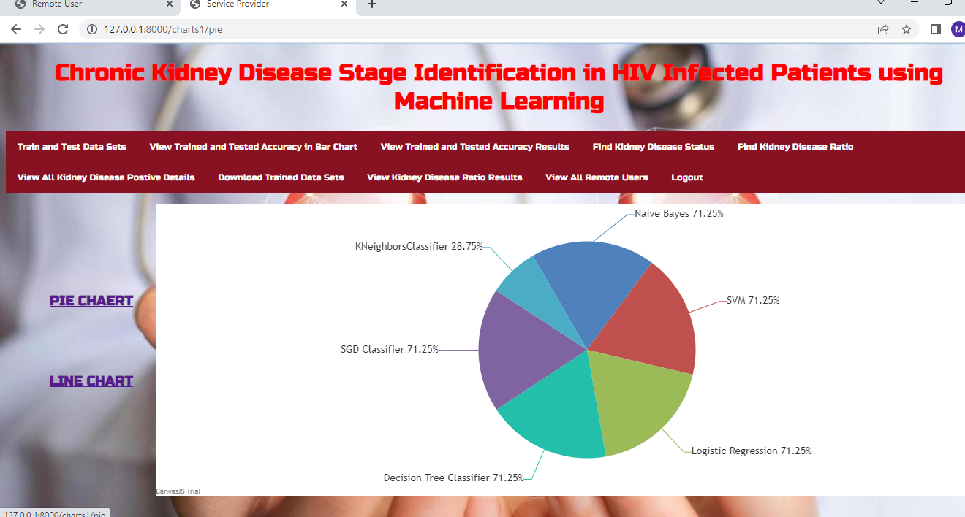

**Figure 9.1: Accuracy comparison**

### 9.2 Remote user:

### User should register before doing any operations. Once user registers, their details will be stored to the database. After registration successful, he has to login by using authorized user name and password. Once Login is successful user will do some operations like POST DIABETIC DATA SETS,VIEW YOUR PROFILE. and user should enter the dataset value for individual person to predict as positive or negative

### Fig 9.2

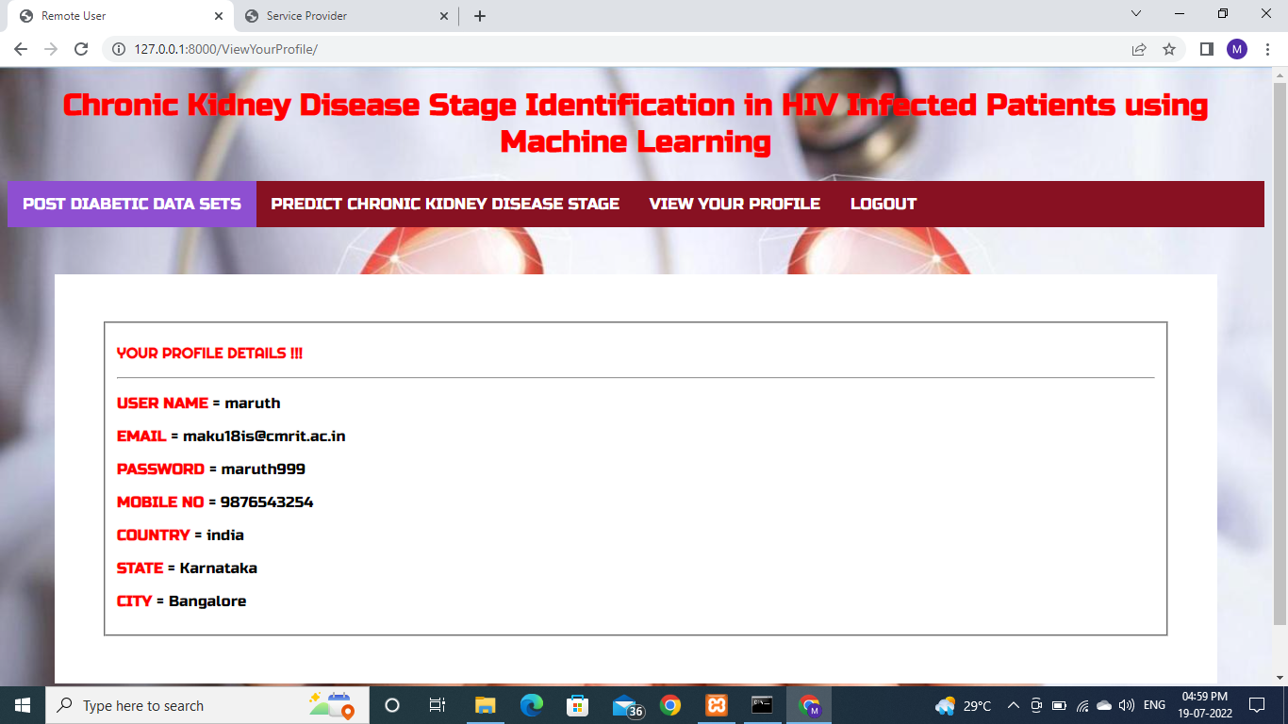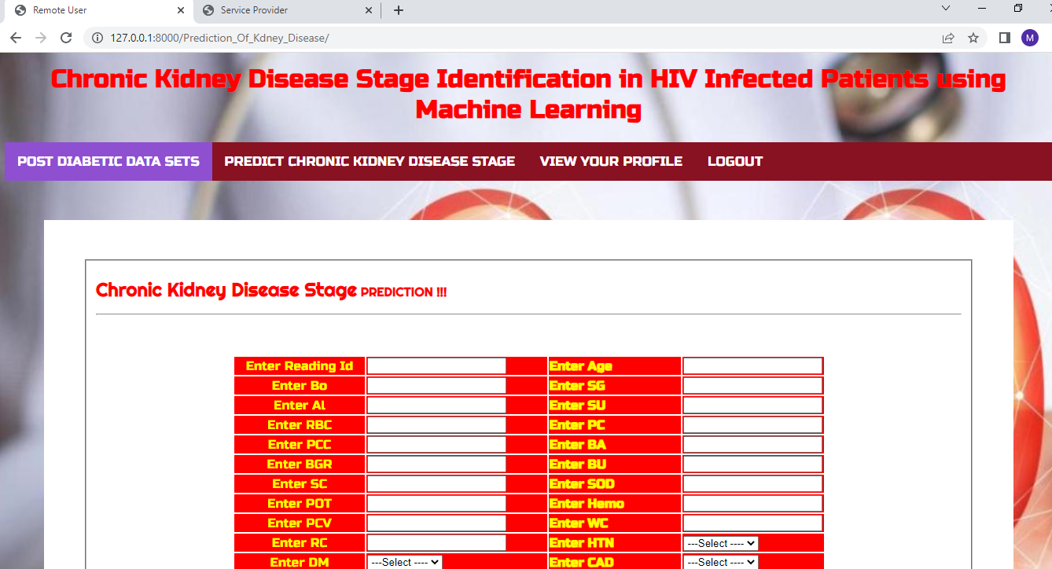

**9.3 Service provider** : the Service Provider has to login by using valid user name and password. After login successful he can do some operations such as Train and Test Data Sets,View Trained and Tested Accuracy in Bar Chart,View Trained and Tested Accuracy Results,Find Kidney Disease Status,Find Kidney Disease Ratio,View All Kidney Disease Positive Details, Download Trained Data Sets,View Kidney Disease Ratio Results,View All Remote Users

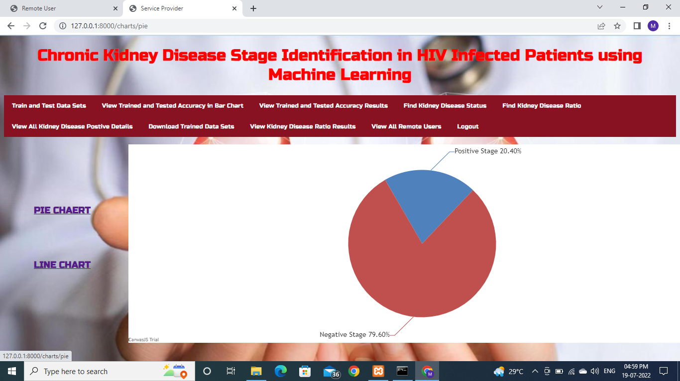Fig 9.3

**9.3 SNAPSHOTS OF OUTPUT**

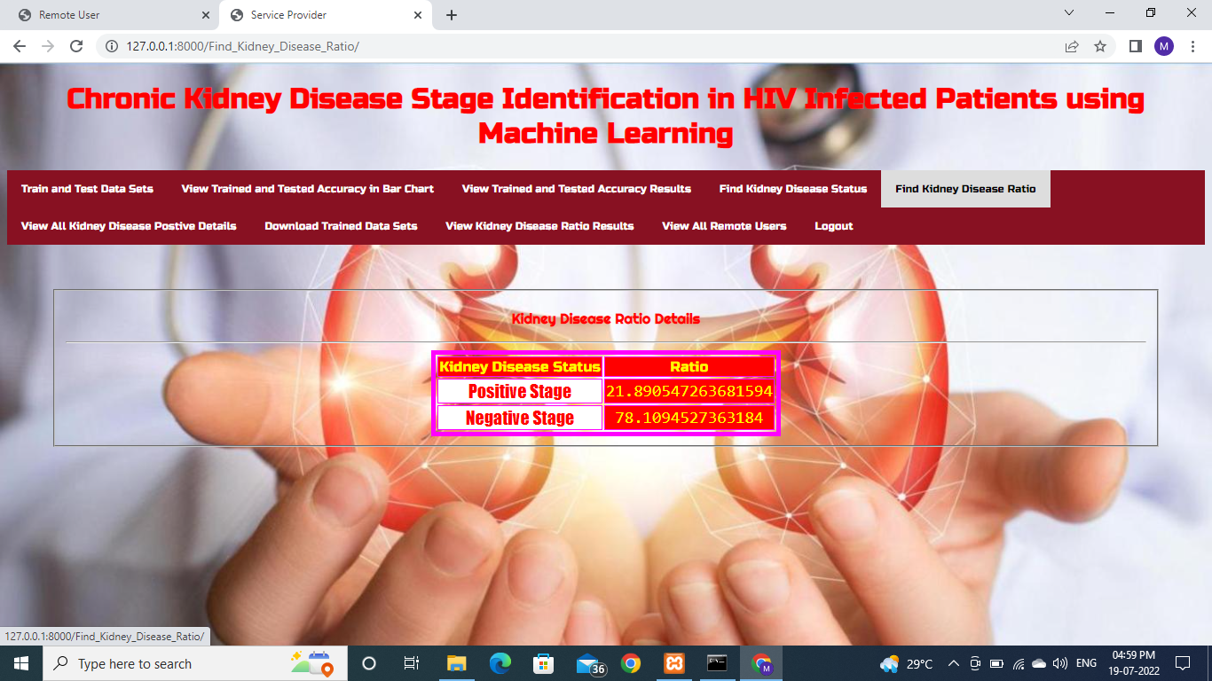

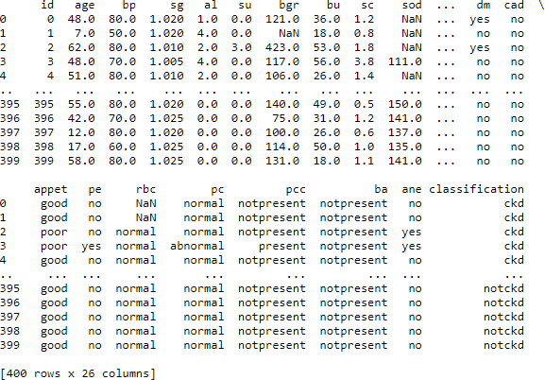

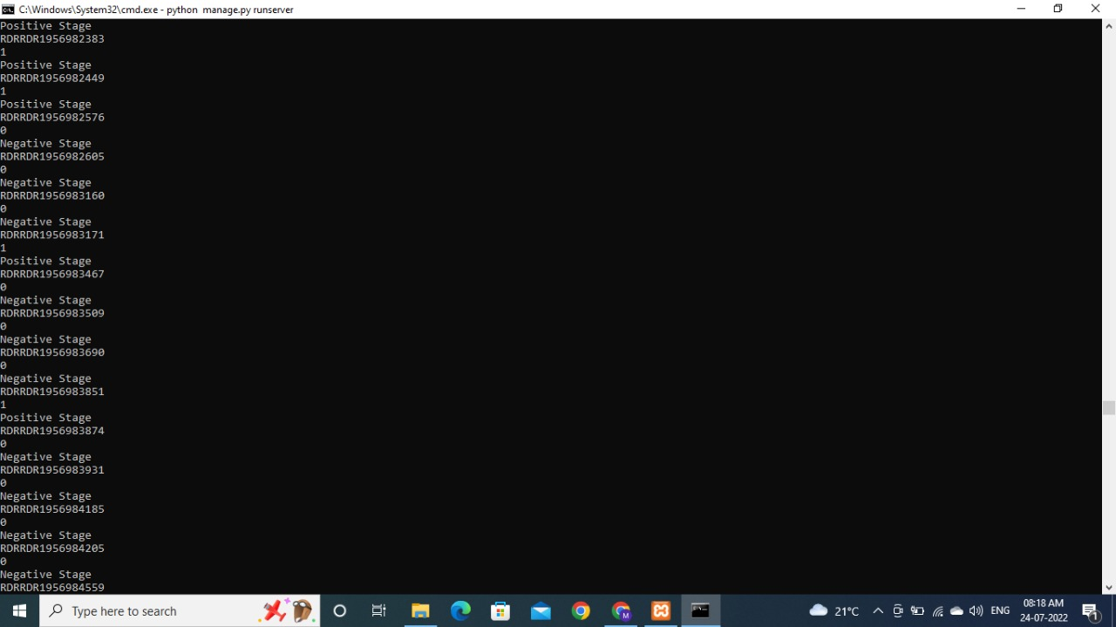

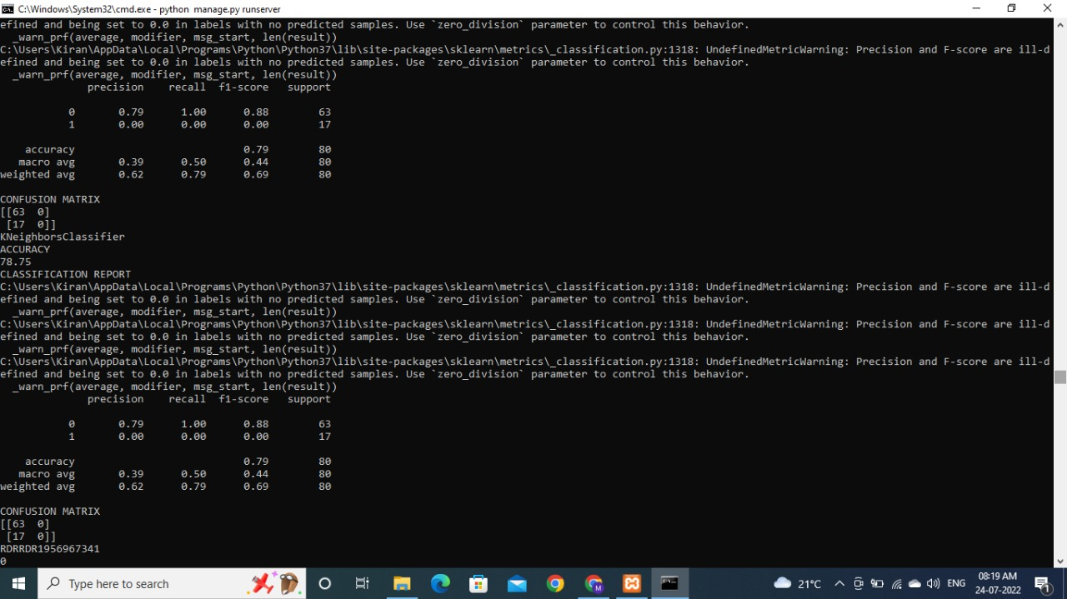

**Figure 9.9: Results for all the models like decision tree etc.**

**Chapter 10**

# CONCLUSION AND FUTURE SCOPE

## FUTURE SCOPE

* This would help detect the chances of a person having CKD further on in his life which would be really helpful and cost-effective people.
* This model could be integrated with normal blood report generation, which could automatically flag out if there is a person at risk.
* Patients would not have to go to a doctor unless they are flagged by the algorithms. This would make it cheaper and easier for the modern busy person.
* In Future even the stages of the CKD in HIV patient can be predicted

## CONCLUSION

This system presented the best prediction algorithm to predict CKD at an early stage. The dataset shows input parameters collected from the CKD patients and the models are trained and validated for the given input parameters. K-Nearest-Neighbors Classifier, Decision Tree Classifier, Naïve Bayes, Logical Regression and SVM, SGD models are constructed to carry out the diagnosis of CKD. The performance of the models is evaluated based on a variety of comparison metrics are being used, namely Accuracy, and also help to predict chronic kidney disease in Hiv infected patient. This system would help detect the chances of a person having CKD further on in his life which would be really helpful and cost-effective people. This model could be integrated with normal blood report generation, which could automatically flag out if there is a person at risk. Patients would not have to go to a doctor unless they are flagged by the algorithms. This would make it cheaper and easier for the modern busy person.

## References

1. M. P. N. M. Wickramasinghe, D. M. Perera and K. A. D. C. P. Kahandawaarachchi, "Dietary prediction for patients with Chronic Kidney Disease (CKD) by considering blood potassium level using machine learning algorithms," 2017 IEEE Life Sciences Conference (LSC), Sydney, NSW, 2017, pp. 300-303
2. U. N. Dulhare and M. Ayesha, "Extraction of action rules for chronic kidney disease using Naïve bayes classifier," 2016 IEEE International Conference on Computational Intelligence and Computing Research (ICCIC), Chennai, 2016, pp.1-5.
3. R. Devika, S. V. Avilala and V. Subramaniyaswamy, "Comparative Study of Classifier for Chronic Kidney Disease prediction using Naïve Bayes, KNN and Random Forest," 2019 3rd International Conference on Computing Methodologies and Communication (ICCMC), Erode, India, 2019, pp. 679-684.
4. G. Kaur and A. Sharma, "Predict chronic kidney disease using data mining algorithms in hadoop," 2017 International Conference on Inventive Computing and Informatics (ICICI), Coimbatore, 2017, pp. 973-979.
5. Arif-Ul-Islam and S. H. Ripon, "Rule Induction and Prediction of Chronic Kidney Disease Using Boosting Classifiers, Ant-Miner and J48 Decision Tree," 2019 International Conference on Electrical, Computer and Communication Engineering (ECCE), Cox'sBazar, Bangladesh, 2019, pp. 1-6.
6. S. Vijayarani, S. Dhayanand, "KIDNEY DISEASE PREDICTION USING SVM AND ANN ALGORITHMS", International Journal of Computing and Business Research (IJCBR), vol. 6, no. 2, 2015
7. Deepti Sisodiaa , Dilip Singh Sisodia, Prediction of Diabetes using three classification algorithms, Computational International Conference on Data Intelligence and Science (ICCIDS 2018)
8. Maryam Soltanpour Gharibdousti Kamran Azimi, Saraswathi Hathikal, Dae H Won, Prediction of Chronic Kidney Disease using Data mining techniques, 2017 Industrial and

Systems Engineering Conference.

1. Krupa Joel Chabathula, Jaidhar C.D, Ajay Kumara M.A Comparative Study of Principal Component Analysis Based Intrusion Detection Approach Using Machine Learning Algorithms , 2015 3rd International Conference on Signal Processing, Communication and Networking (ICSCN).
2. Guneet Kaur , Ajay Sharma , Predict Chronic Kidney Disease Using Data Mining Algorithms in Hadoop , International Journal of Advanced Computational Engineering and Networking,

ISSN: 2320-2106, Volume-5, Issue- 6, Jun-2017

1. "UCI Machine Learning Repository: Chronic_Kidney_DiseaseDataSet",Archive.ics.uci. edu,2015.Availa[ble:htt](http://archive.ics.uci.edu/ml/datasets/Chronic_Kidney_Disease)p:/[/ar](http://archive.ics.uci.edu/ml/datasets/Chronic_Kidney_Disease)c[hive.ics.uci.edu/ml/datasets/Chronic_Kidney_Disease](http://archive.ics.uci.edu/ml/datasets/Chronic_Kidney_Disease)
2. [www.kidneyfund.org/kidneydisease/chronic-kidney-diseaseckd/](http://www.kidneyfund.org/kidneydisease/chronic-kidney-diseaseckd/)